Chapter II:
Physical training in formula One

- Introduction: Hight level athlets are the Formula One of performance
Much attention is given to the mechanical side of Formula One. Equal consideration must be accorded to the racing driver.
This chapter shows only the main headlines of the physical preparation and the tools needed for the racing driver. Benoit Campargue and Sport Management System’s team has created a concept for the preparation of racing drivers. We are available to talk and develop these different aspects with you.
- Physical fitness enables athletes to achieve their maximum physical and psychological potential

- Physiological capacities :

- Endurance: the ability to maintain aerobic exercise.
- Stamina: why and wherefore? …
    - When? …
    - How? …

This method may be used as a general physical preparation. It is of particular interest during the second half of the off-season which is a development period. This method is the one most frequently chosen by racing drivers. However, it does not take into account the specific rigors of this sport, the significant changes of rhythm and considerable anaerobic phases (that were evoqued in chapter 1).

- Resistance: the body’s ability to maintain a relatively intense anaerobic effort.

- Resistance : wherefore in Formula one? …
- When ? …
- How? …
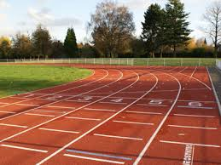

- Physical capacity

- Physical endurance: the capacity to maintain aerobic exercise.

  - Why and wherefore in Formula 1? …
  - How? …
  - When? …
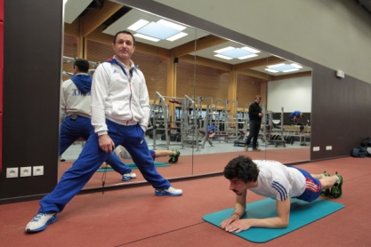

- Physical strength: ability to generate a high level muscular contraction.

  - Why and wherefore in Formula 1? …
  - How? …
  - When? …

- Muscle Power: ability to achieve maximum strength in minimum time.
It is unnecessary for racing car drivers contrary to motorcycle drivers, particularly when braking.
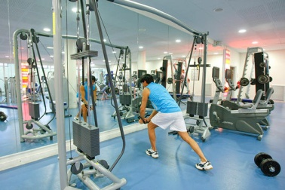

3- Tools

- Body building:
- Advantages in Formula 1: …
- Why ? …
- How ? …
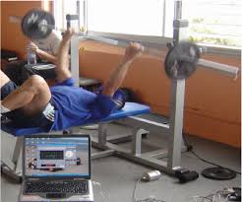

- Athletics:
- Advantages in Formula 1: …
- When ? …
- How ? …
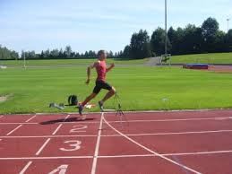

- Judo:
- Which benefits in Formula 1?
  - Gestural : …
  - Physical : …
  - Mental : …
- When ? …
- How ? …
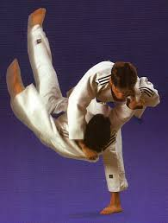

- Ball sports:
- Which benefits in Formula 1?
  - Gestural : …
  - Physical: …
  - Mental: …
  - Tactical: …
- When ? …
- How ? …
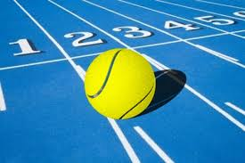

- Cycling:
- What advantages in Formula 1 ?
  - Gestural : …
- Physical: …
- Mental: …
- When ? …
- How ? …
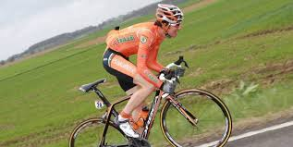
- Swimming :
- Which benefits in Formula 1? (with Mrs. J. Delord ex france Olympic team member) …
    - Gestural: …
    - Physical: …
    - Mental: …
- When ? …
- How ? …
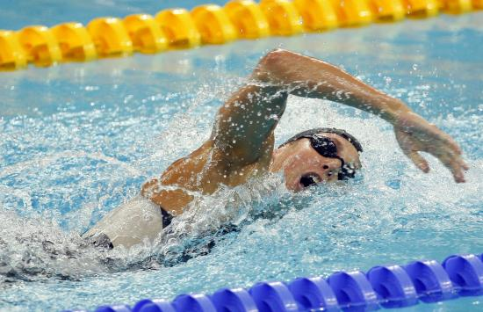

- Others sports like shooting could be practiced. They promote others skills such as concentration, breathing, apnea (for the former). For the latter, endurance, strength endurance and cardio-respiratory aspects will be developed.

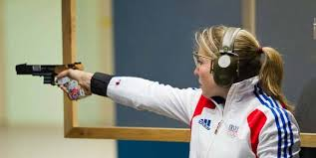

4- Warm up and recovery time
Every session starts with a warm-up and finishes with recovery time and stretching. Warm up should last at least 10 minutes and should comprise light exercises. At the end of each session, 5 to 10 minutes of active recovery time should be followed by stretching …

For any information, please contact:
Sport Management System

